Table of Contents

# Sensitivity Analysis

## Sensitivity Analysis for Raltegravir 100 mg filmcoated tablet md

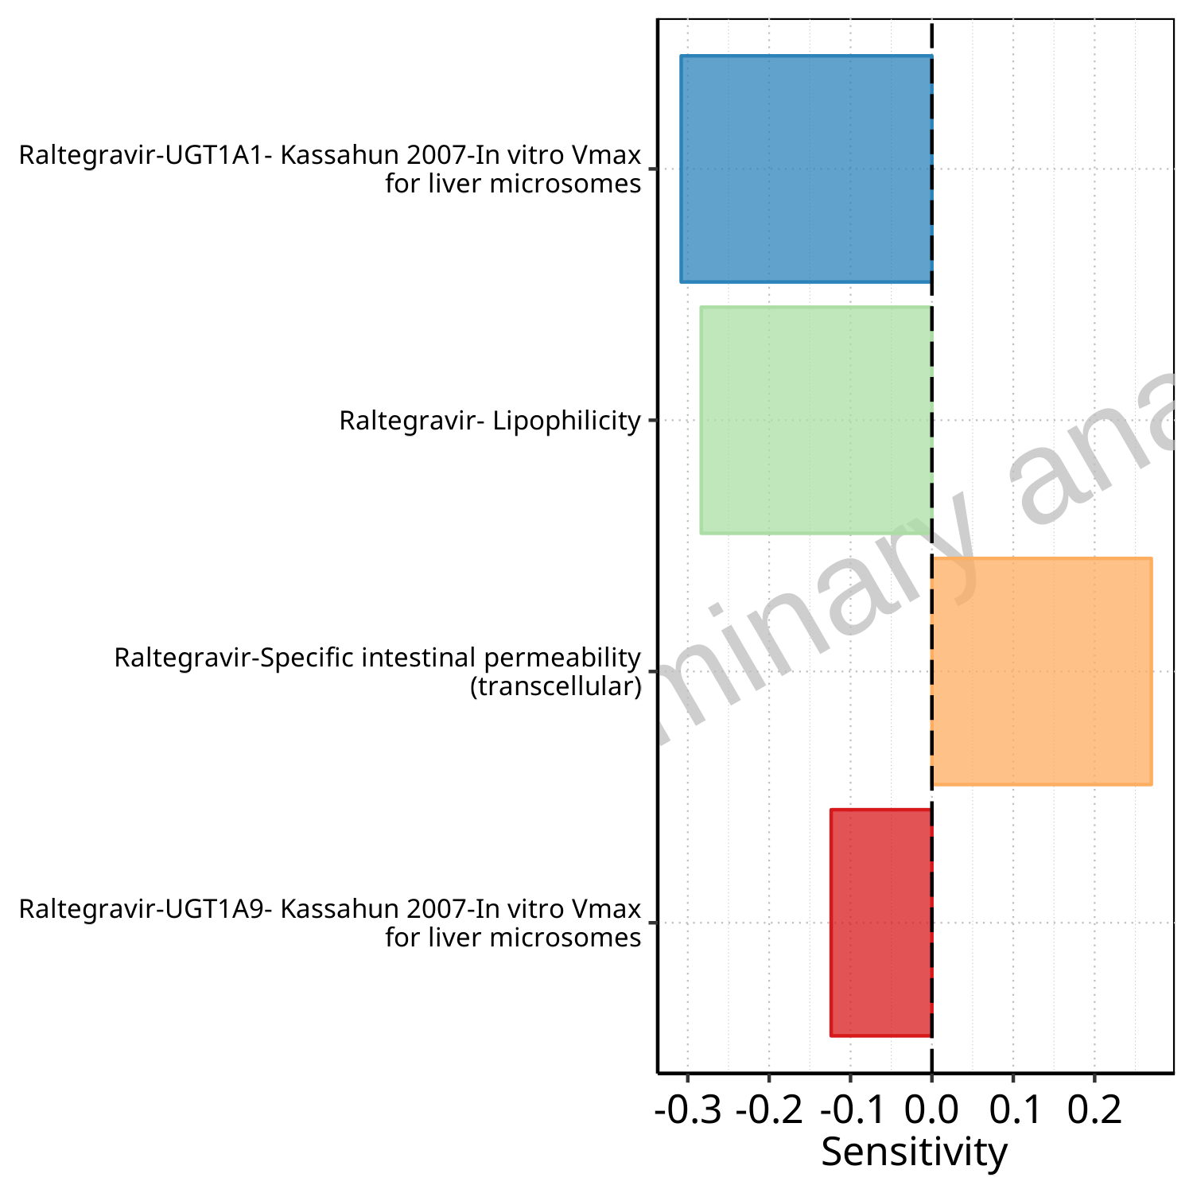

**Figure 1-1: Most sensitive parameters for C_max of Raltegravir.**

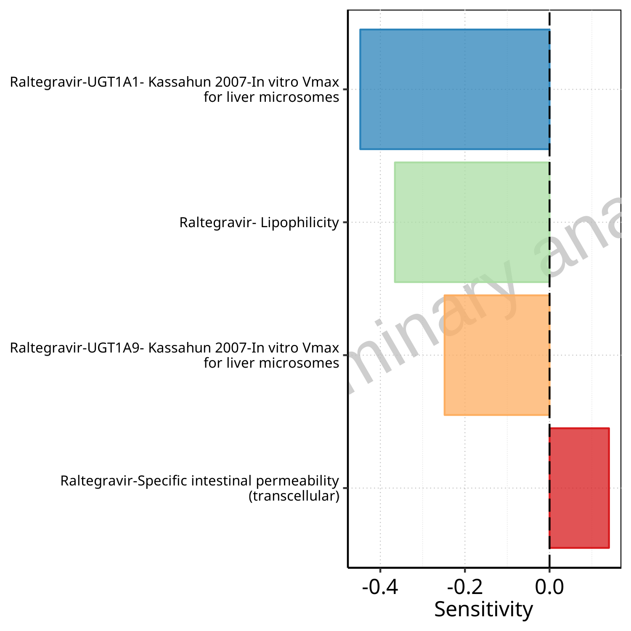

**Figure 1-2: Most sensitive parameters for AUC_t1_t2 of Raltegravir.**

# PK parameters

## PK parameters for Raltegravir 100 mg filmcoated tablet md

**Table 2-1: PK parameters for Scenario Raltegravir 100 mg filmcoated tablet md**

| Path | Parameter | Value | Unit |
| --- | --- | --- | --- |
| Raltegravir | C_max | 894.09 | µg/l |
| Raltegravir | AUC_t1_t2 | 1963.32 | µg*h/l |

# Absorption

## Absorption for Raltegravir 100 mg filmcoated tablet md

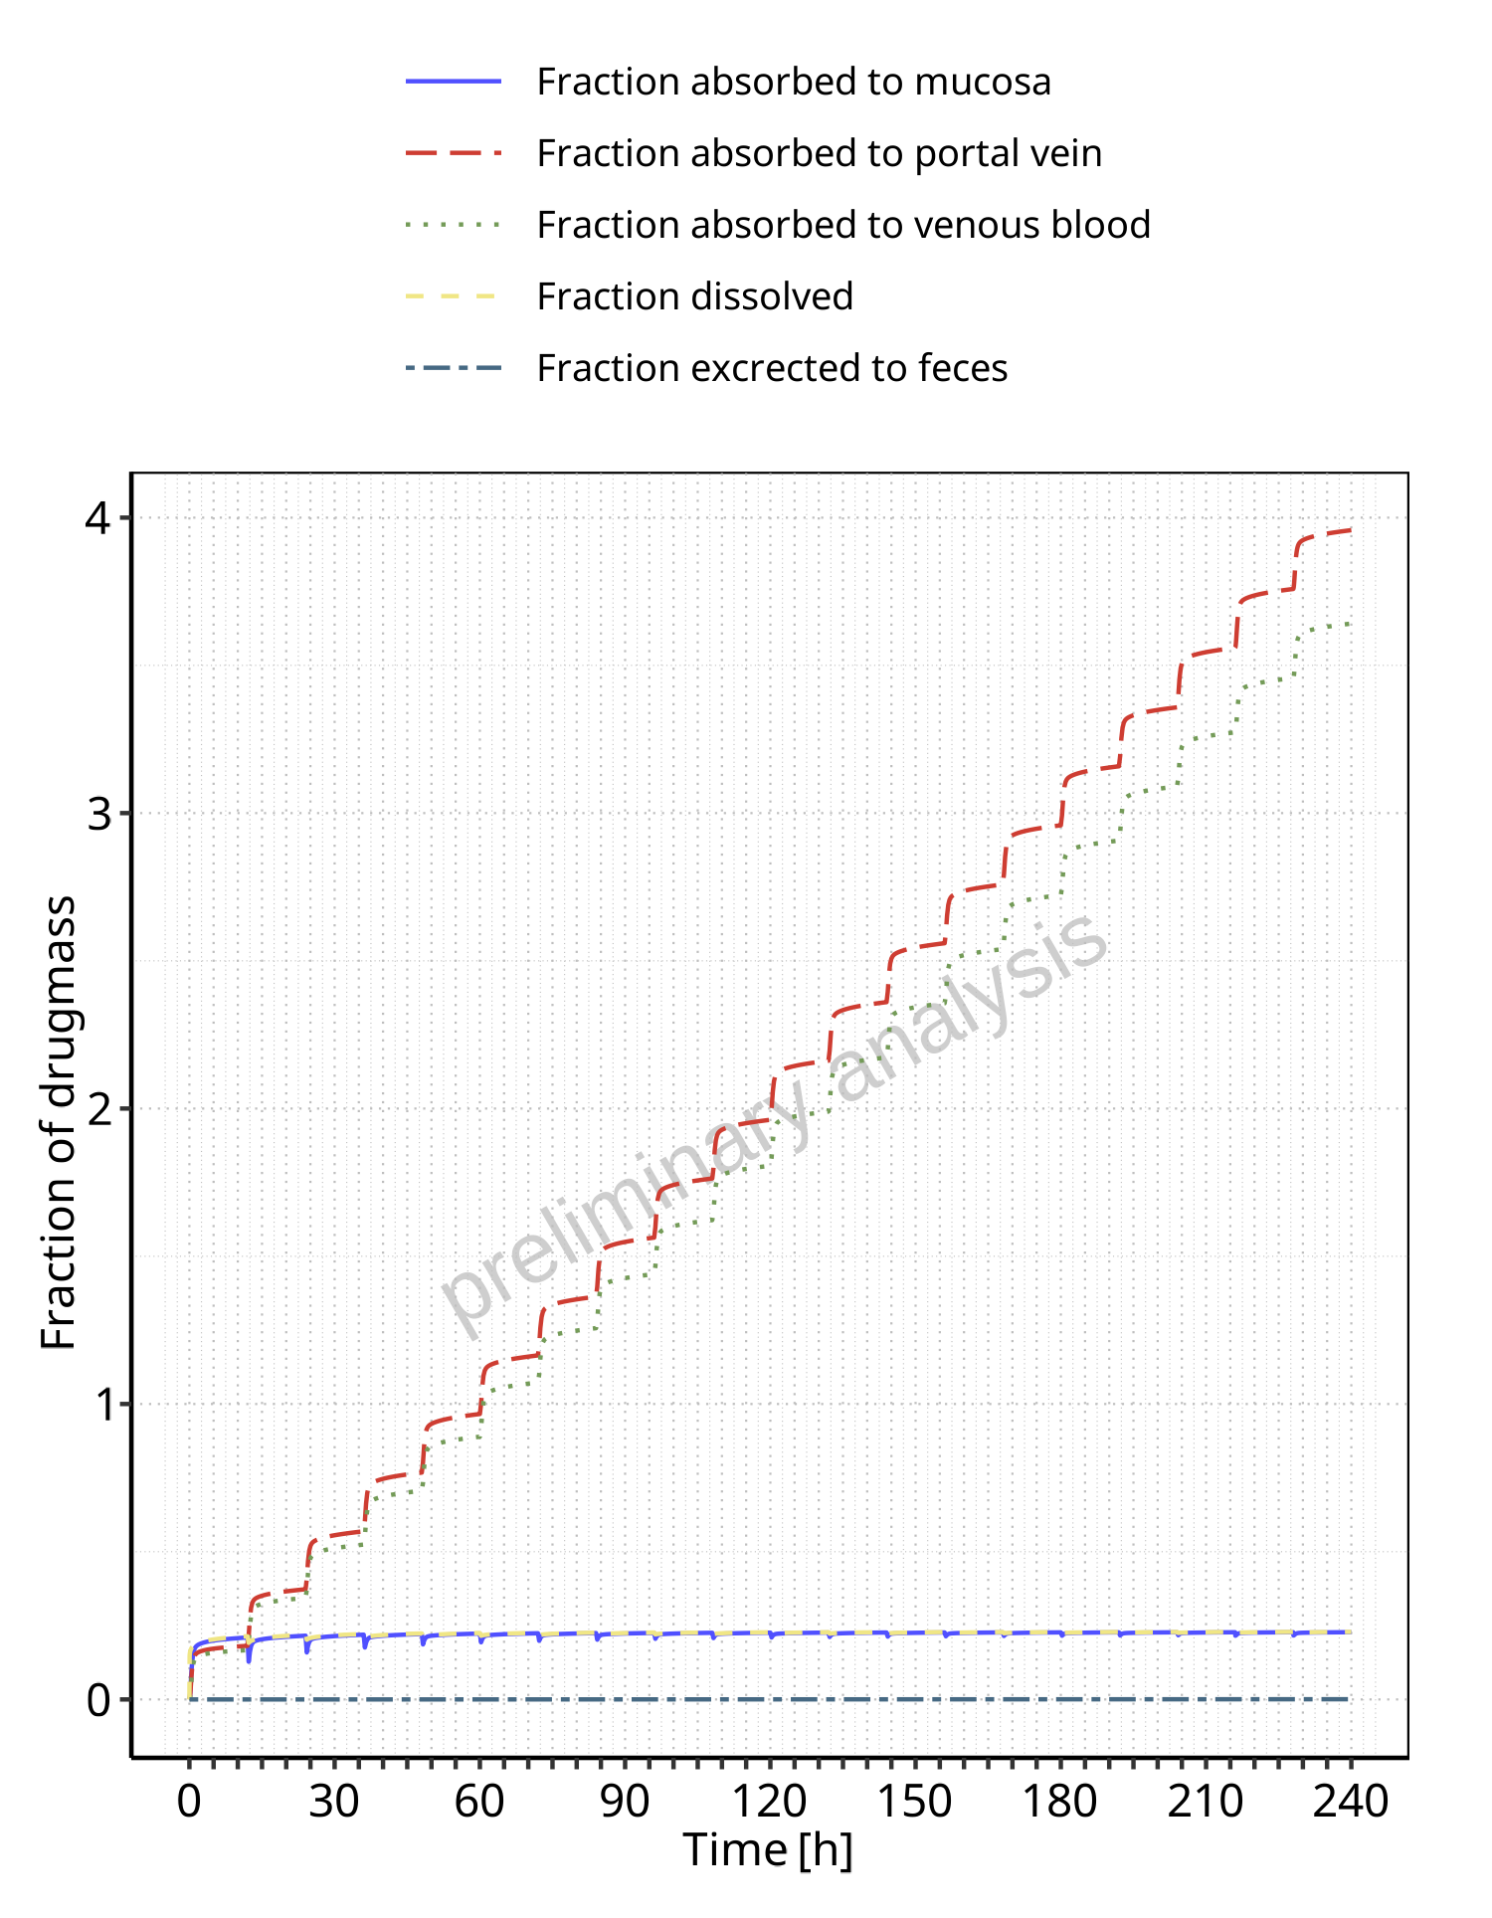

**Figure 3-1: Absorption of Raltegravir**

# Mass Balance

## Mass Balance for Raltegravir 100 mg filmcoated tablet md

### Mass Balance for Raltegravir

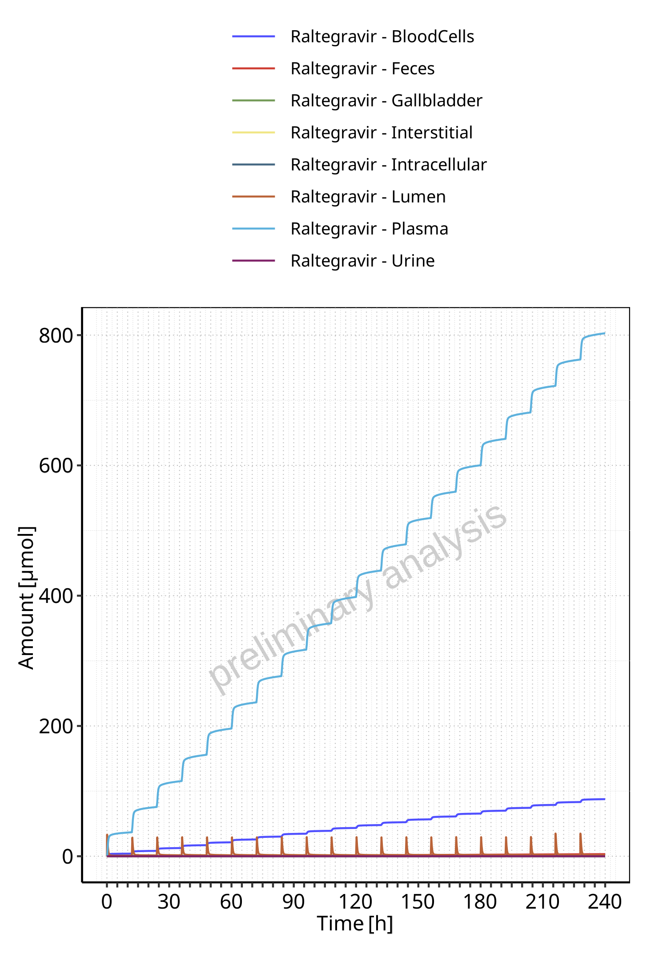

**Figure 4-1: Amount of drug vs time within the different compartments for Raltegravir**

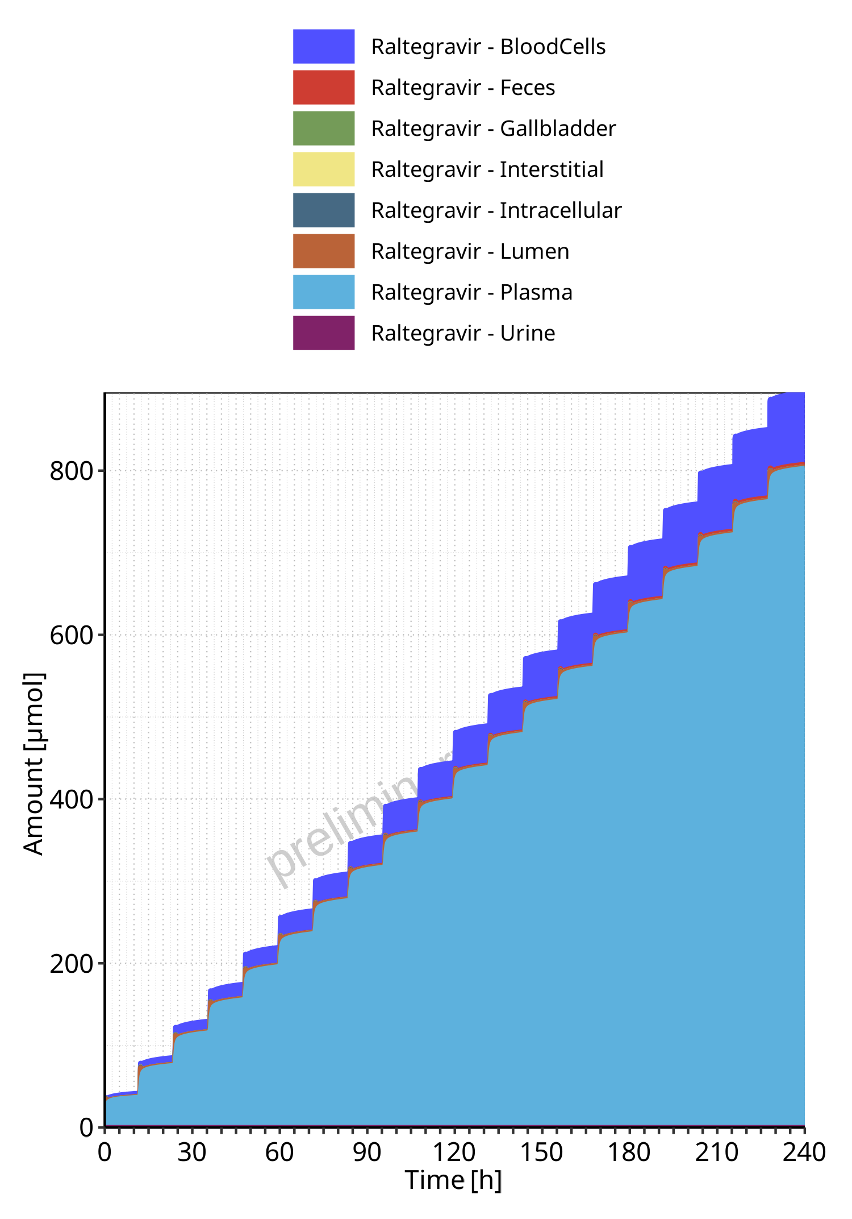

**Figure 4-2: Cumulated amount of drug vs time within the different compartments for Raltegravir**

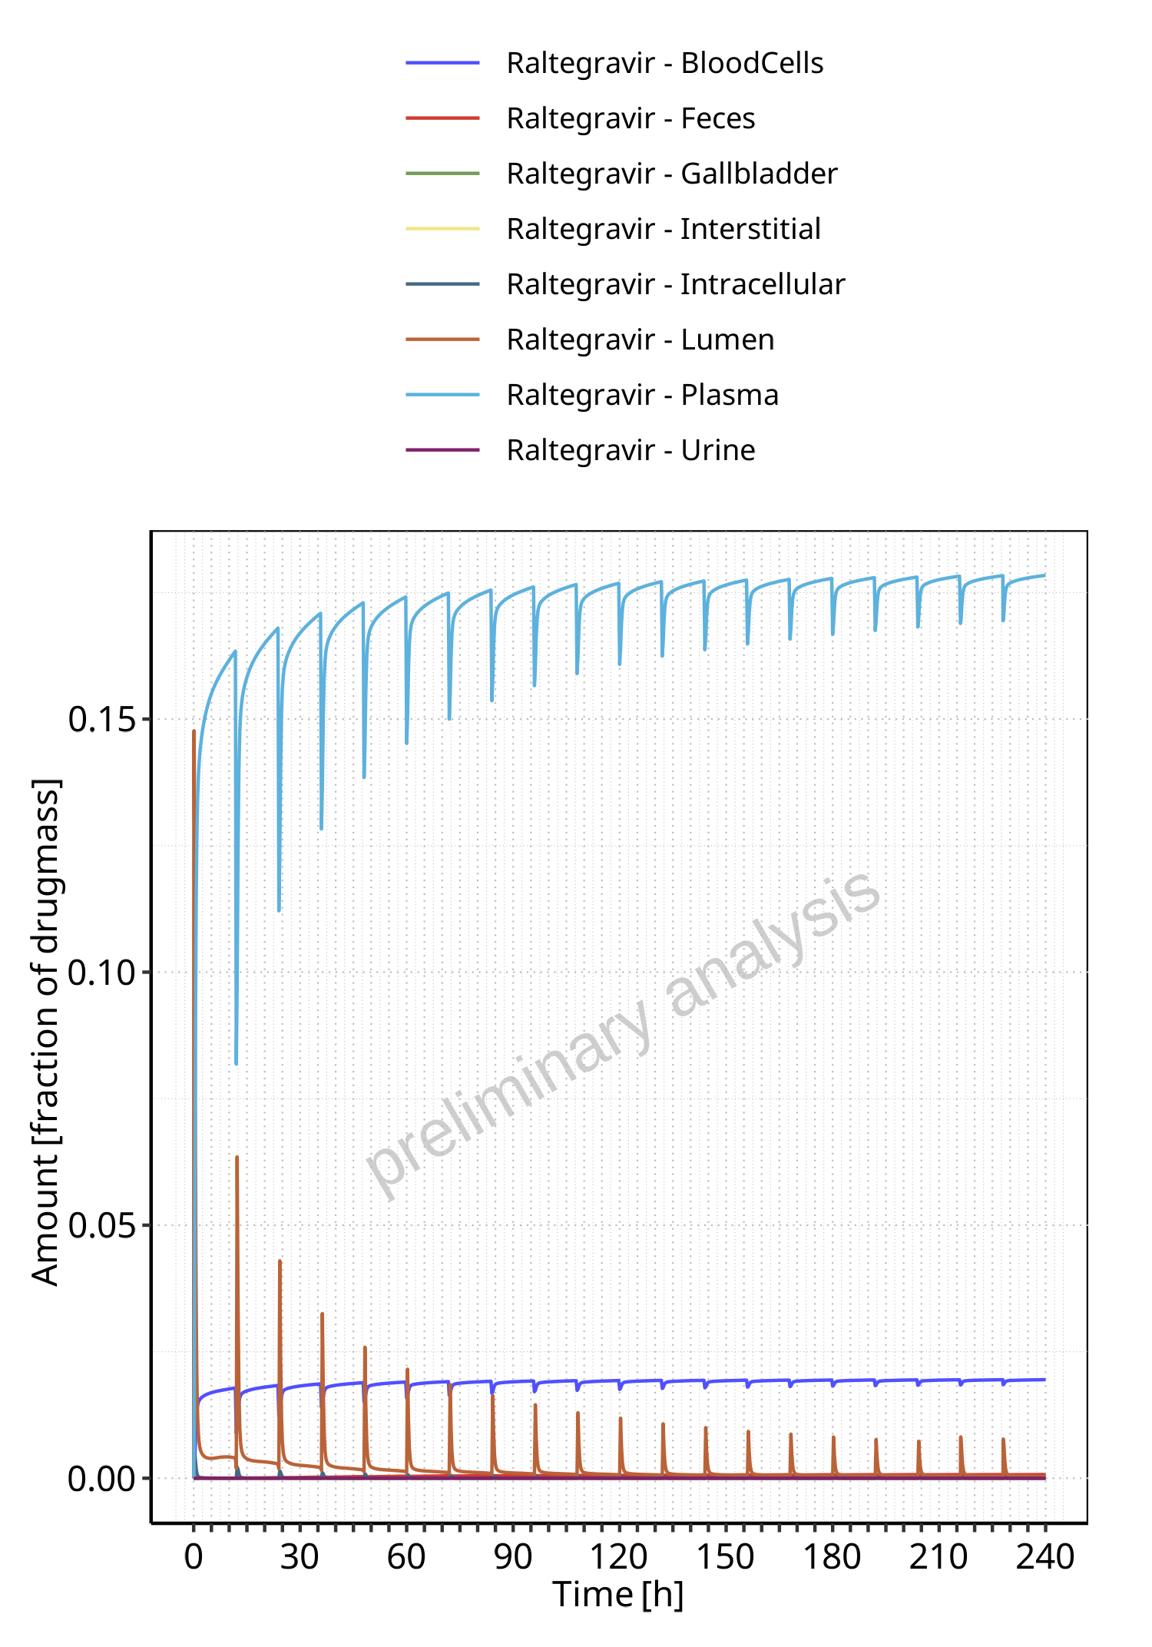

**Figure 4-3: Amount of drug vs time within the different compartments normalized to applicated drugmass for Raltegravir**

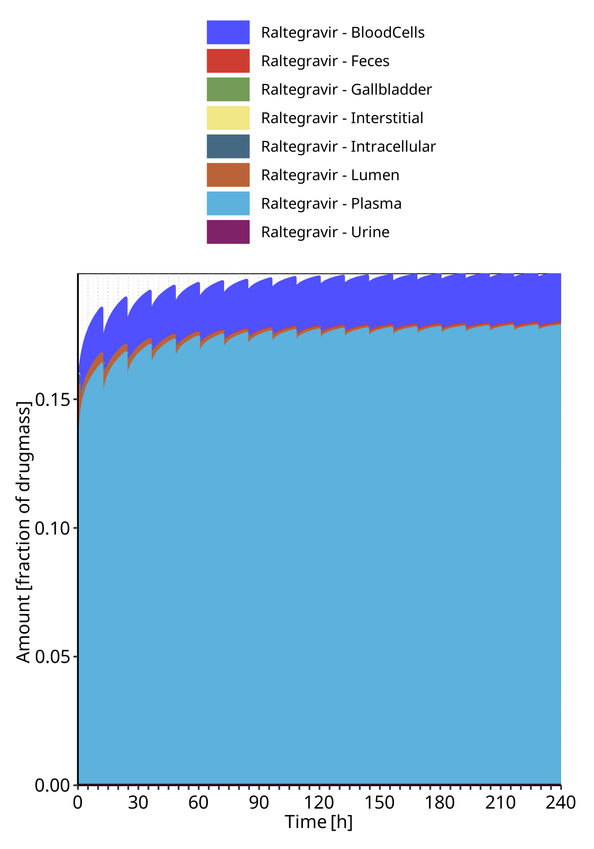

**Figure 4-4: Cumulated amount of drug vs time within the different compartments normalized to applicated drugmass for Raltegravir**

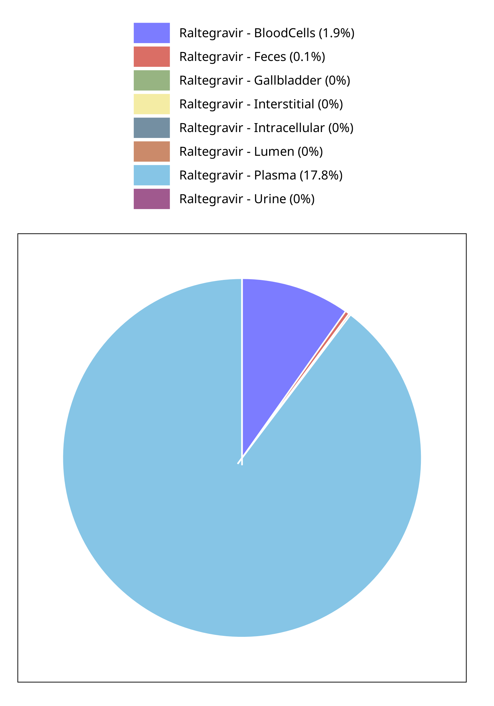

**Figure 4-5: Fraction of drug within the different compartments at 240.00h for Raltegravir**

# Time profiles and residual plots

## Time profiles and residual plots for Raltegravir 100 mg filmcoated tablet md

### For total simulation time range

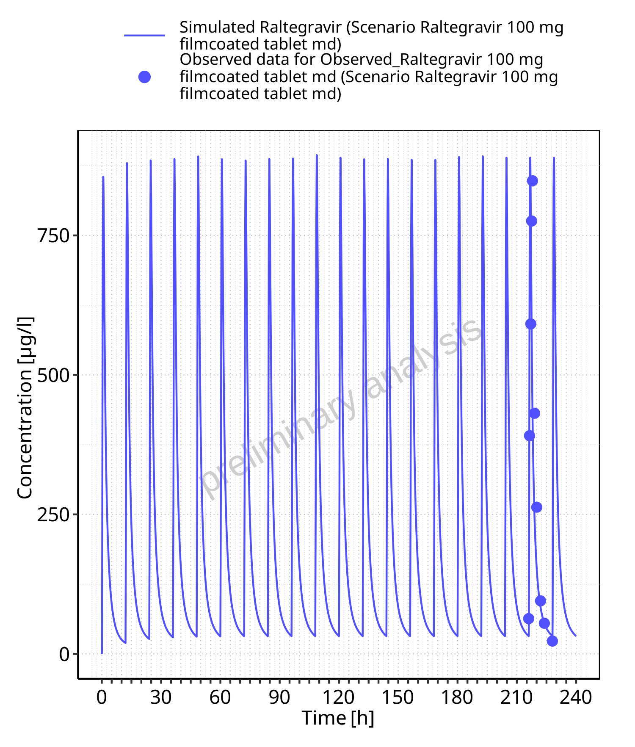

**Figure 5-1: Time profiles for Scenario Raltegravir 100 mg filmcoated tablet md. Data source: Data/Raltegravir_PK.txt. Time profiles are plotted in a linear scale.**

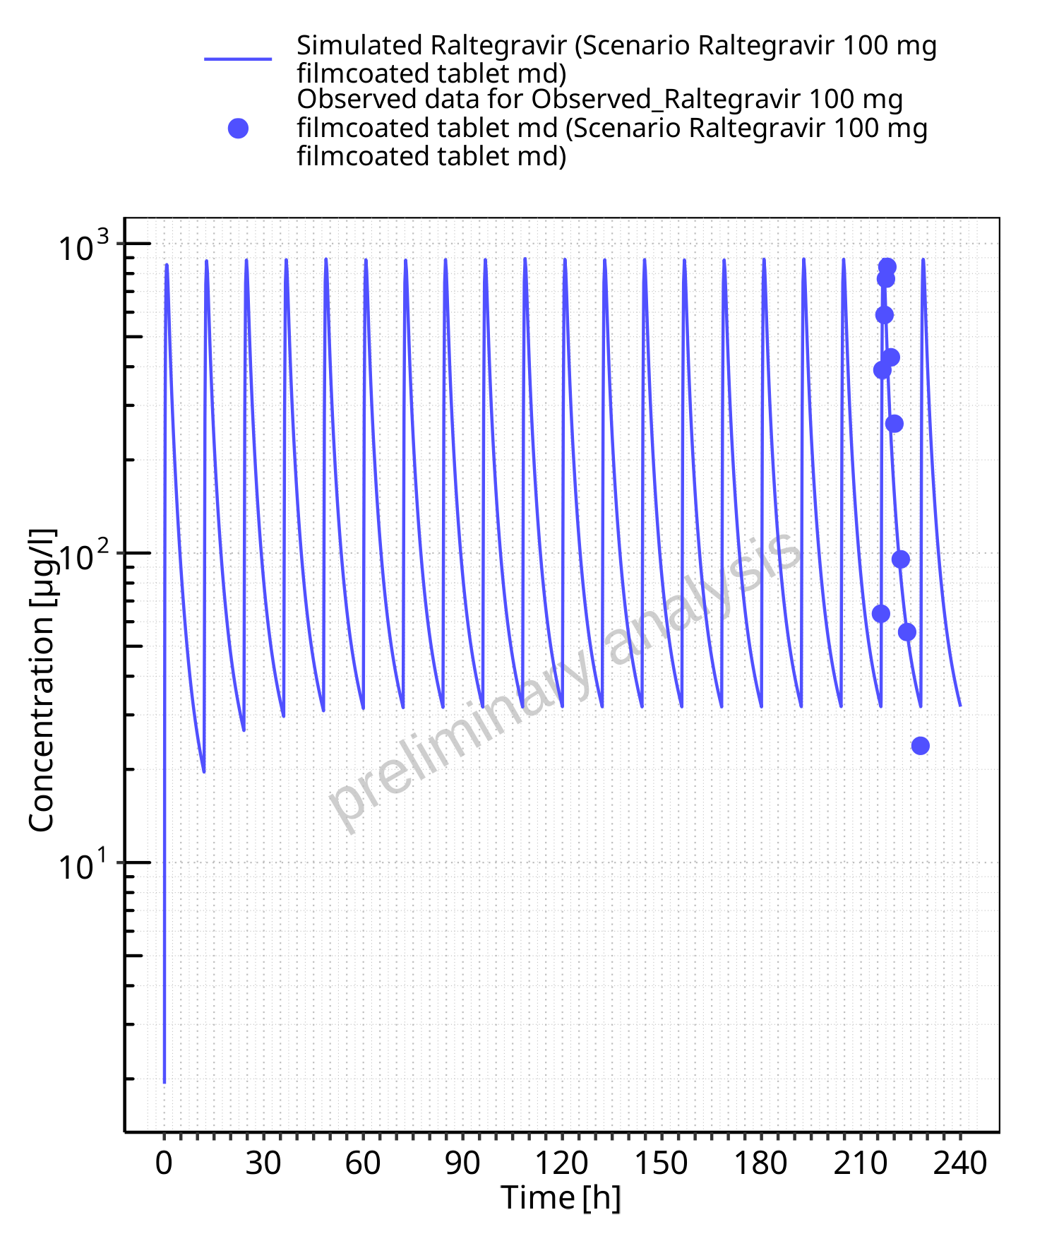

**Figure 5-2: Time profiles for Scenario Raltegravir 100 mg filmcoated tablet md. Data source: Data/Raltegravir_PK.txt. Time profiles are plotted in a logarithmic scale.**

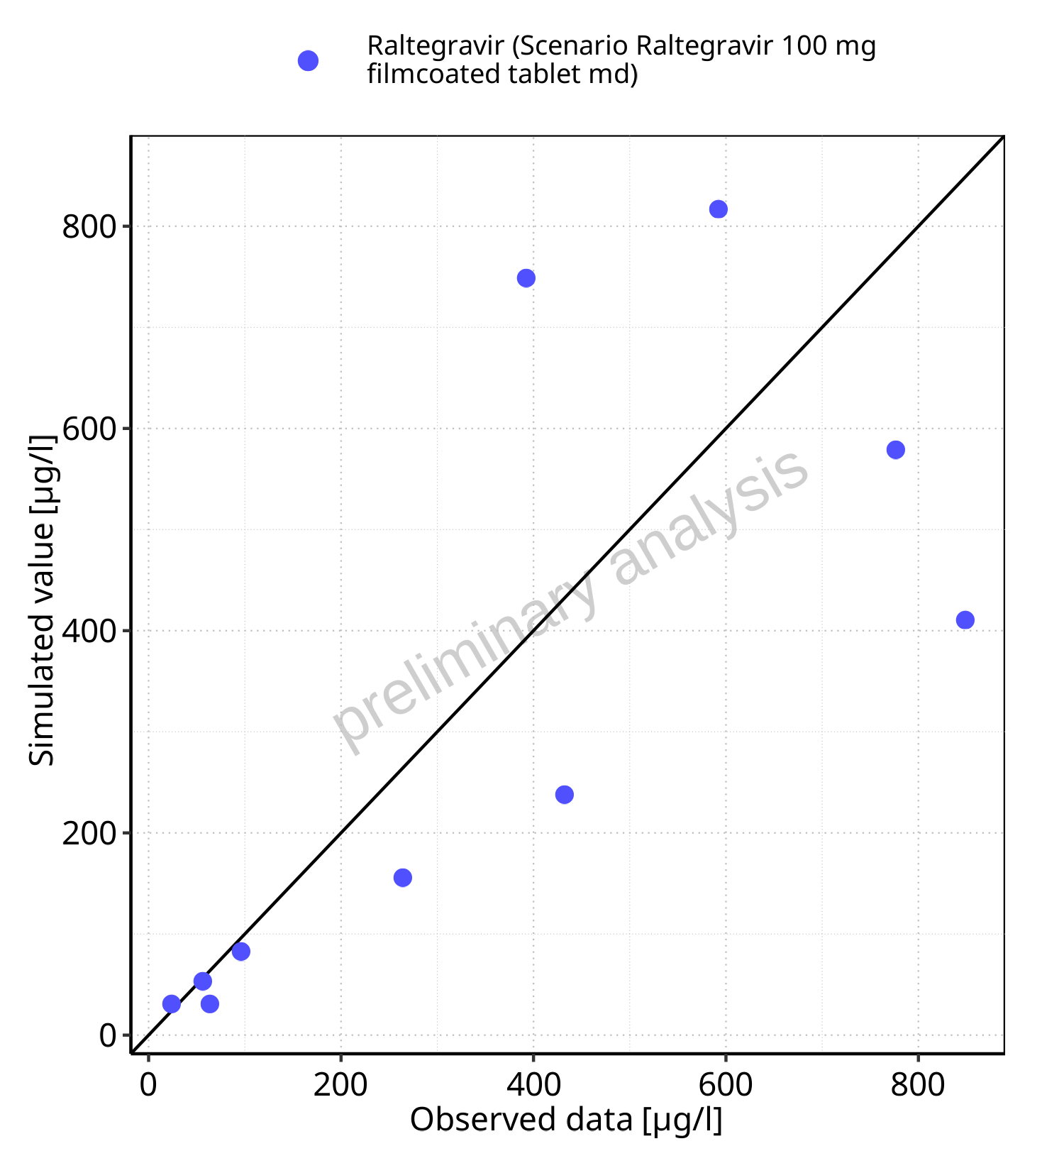

**Figure 5-3: Predicted vs observed for Scenario Raltegravir 100 mg filmcoated tablet md. Data source: Data/Raltegravir_PK.txt. Predictions and observations are plotted in a linear scale.**



**Figure 5-4: Predicted vs observed for Scenario Raltegravir 100 mg filmcoated tablet md. Data source: Data/Raltegravir_PK.txt. Predictions and observations are plotted in a logarithmic scale.**

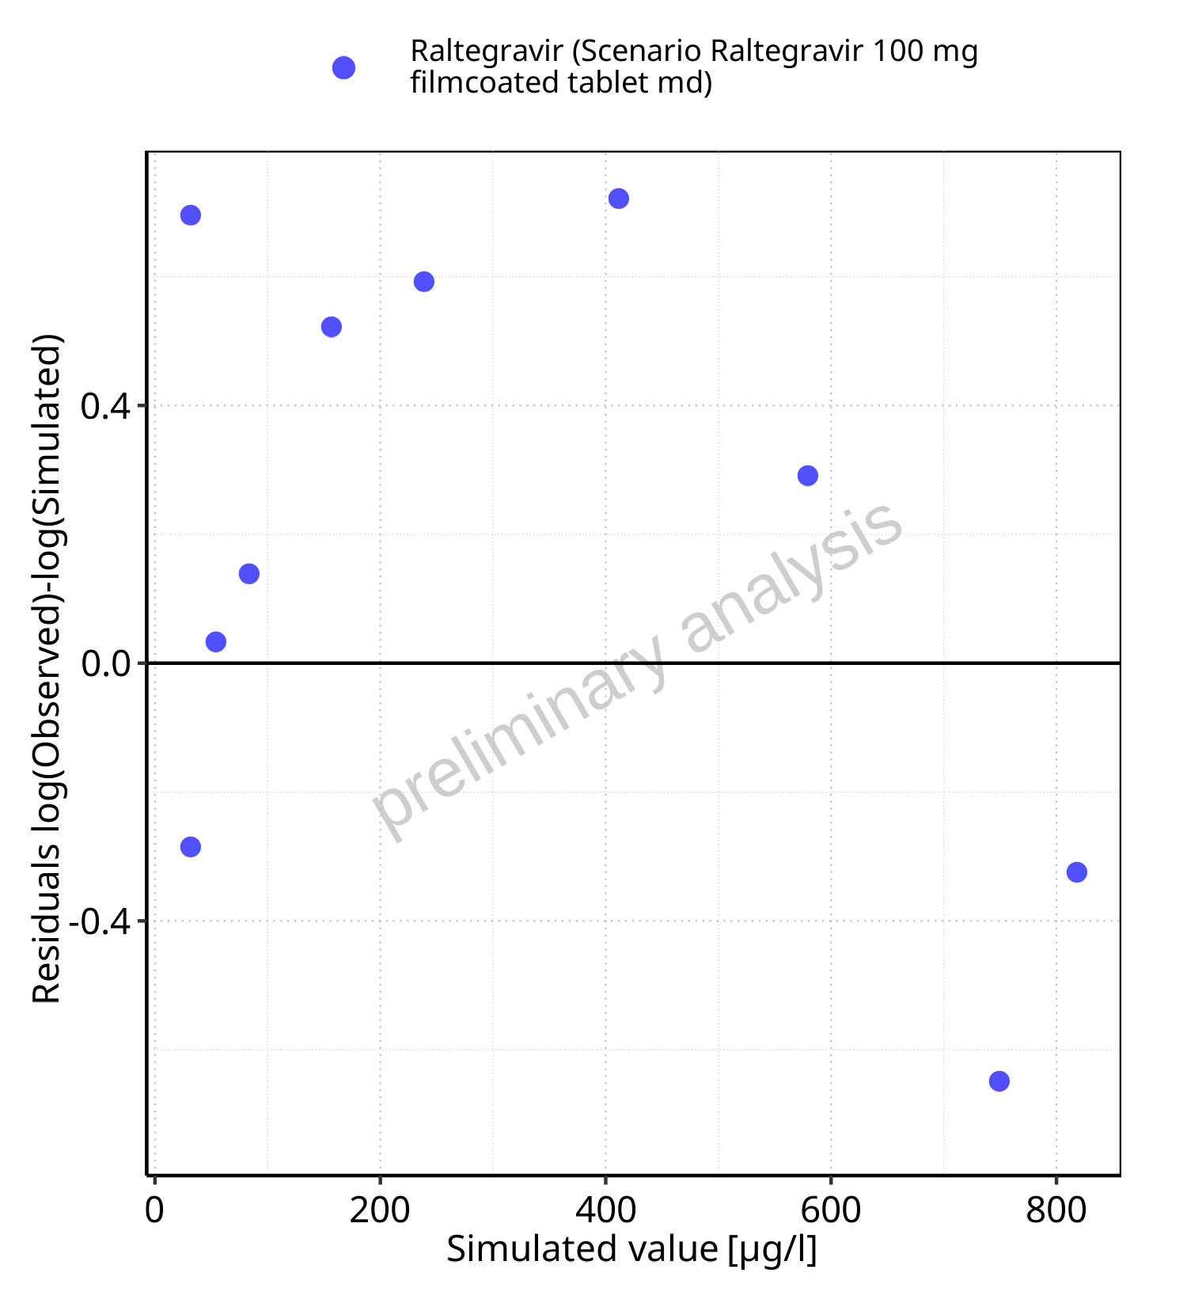

**Figure 5-5: Logarithmic residuals vs predicted values for Scenario Raltegravir 100 mg filmcoated tablet md. Data source: Data/Raltegravir_PK.txt.**

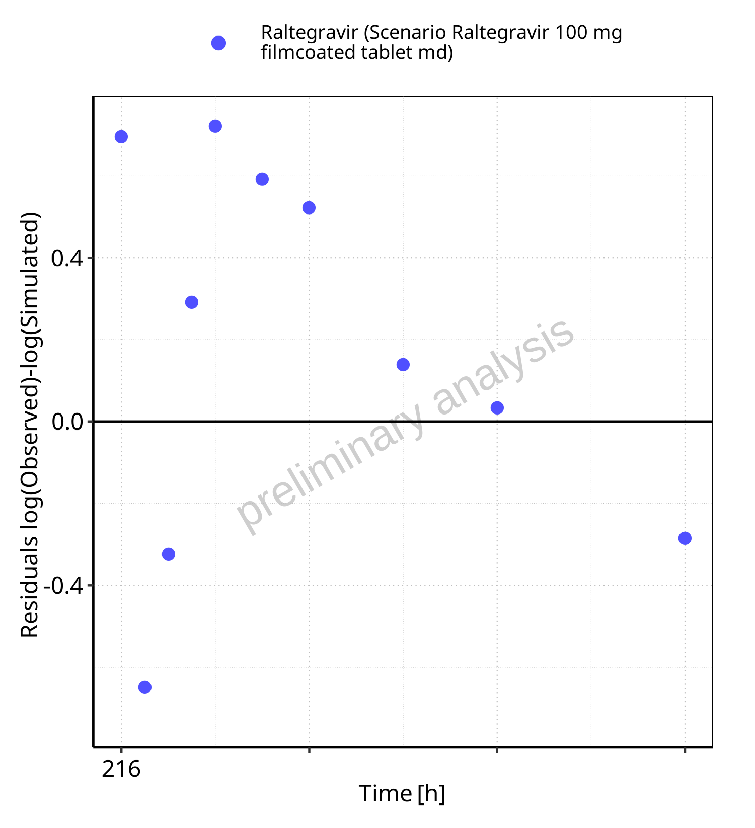

**Figure 5-6: Logarithmic residuals vs time values for Scenario Raltegravir 100 mg filmcoated tablet md. Data source: Data/Raltegravir_PK.txt.**

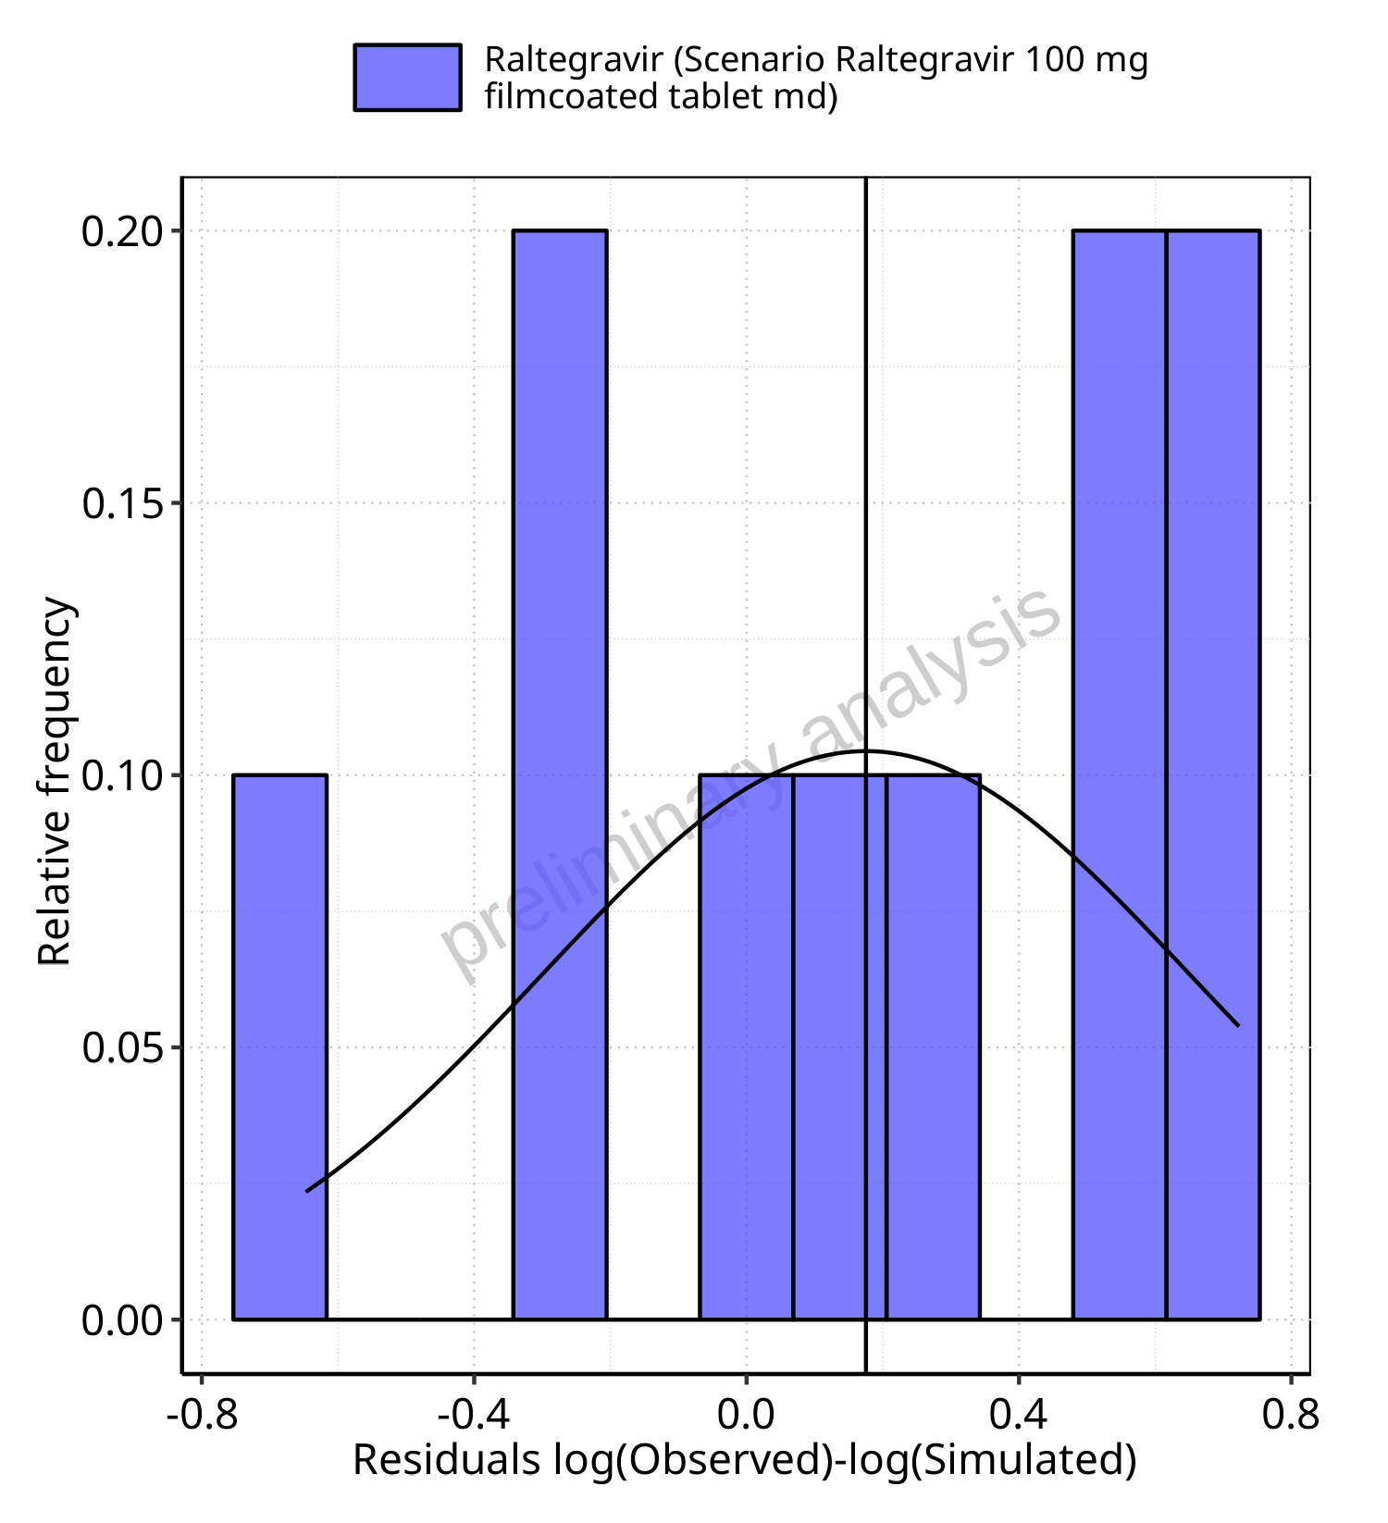

**Figure 5-7: Logarithmic residuals distribution (stacked) for Scenario Raltegravir 100 mg filmcoated tablet md. Data source: Data/Raltegravir_PK.txt.**

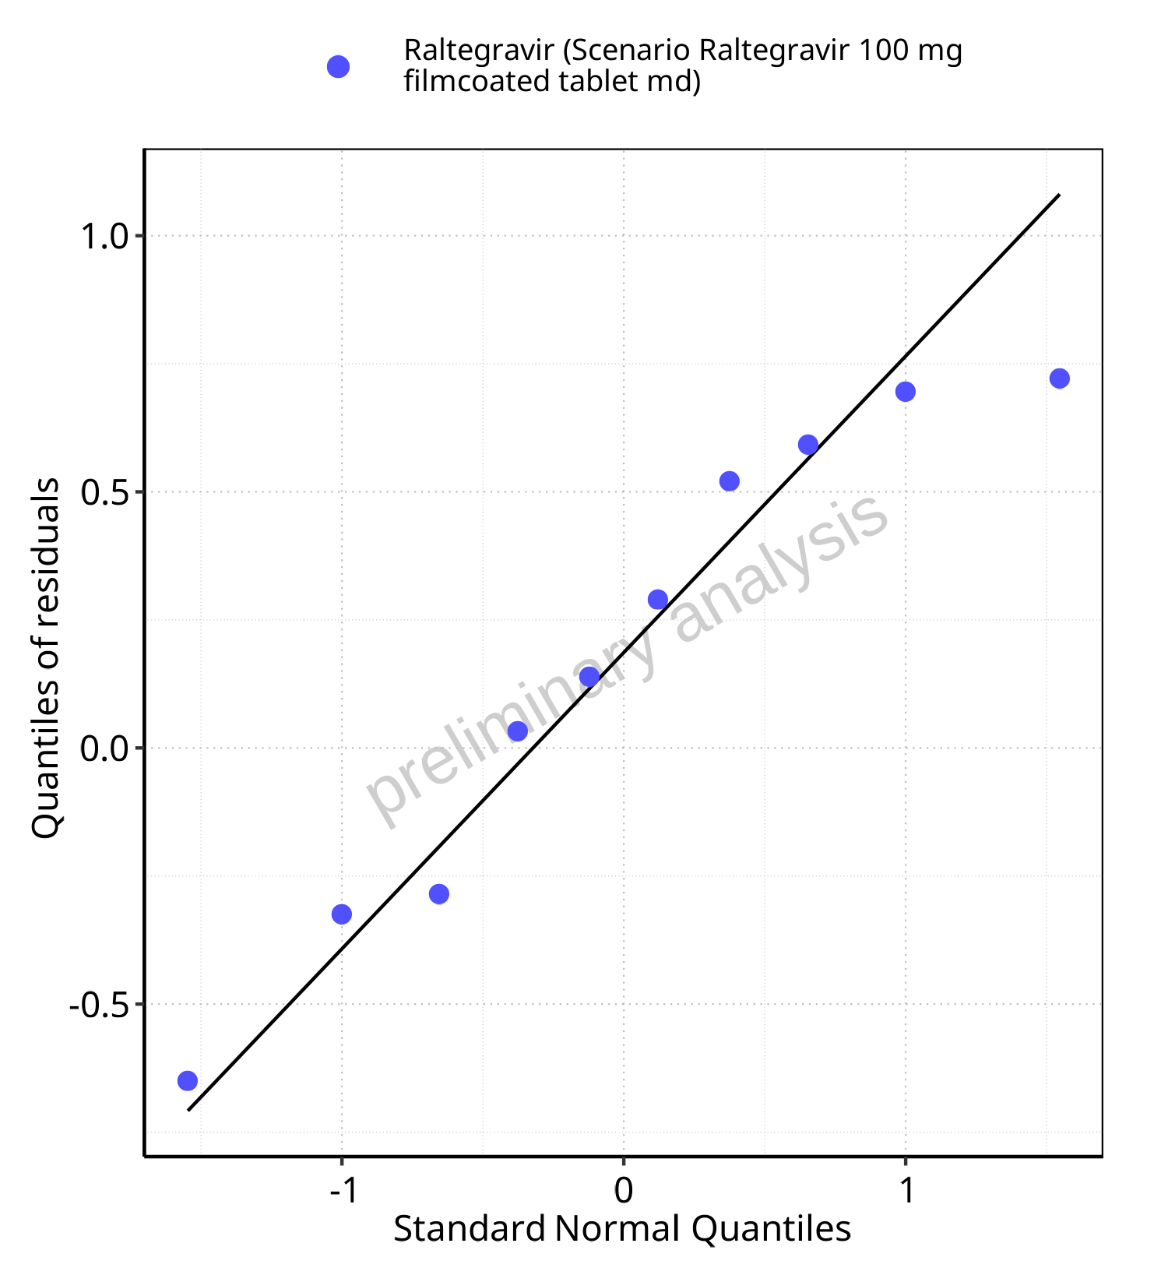

**Figure 5-8: Logarithmic residuals for Scenario Raltegravir 100 mg filmcoated tablet md as quantile-quantile plot. Data source: Data/Raltegravir_PK.txt.**

### For first application range

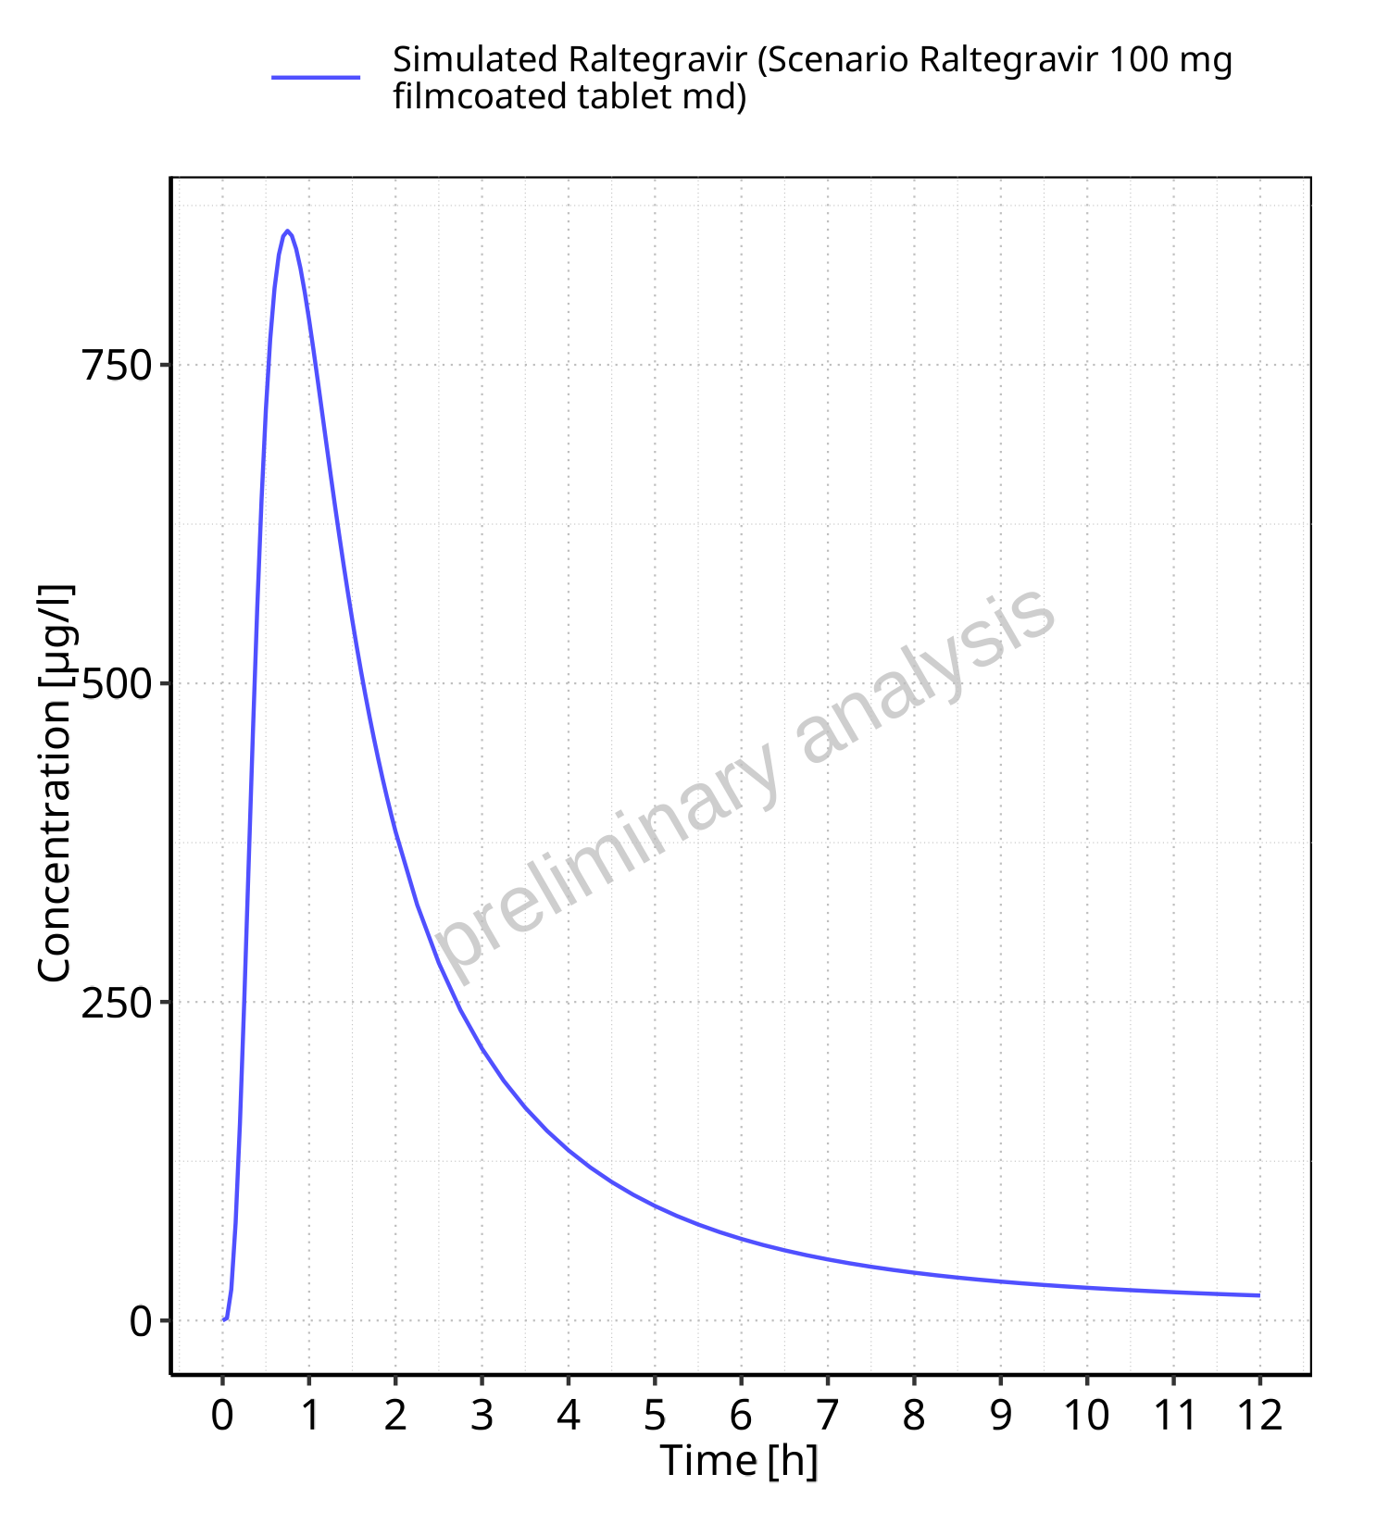

**Figure 5-9: Time profiles for Scenario Raltegravir 100 mg filmcoated tablet md. Data source: Data/Raltegravir_PK.txt. Time profiles are plotted in a linear scale.**

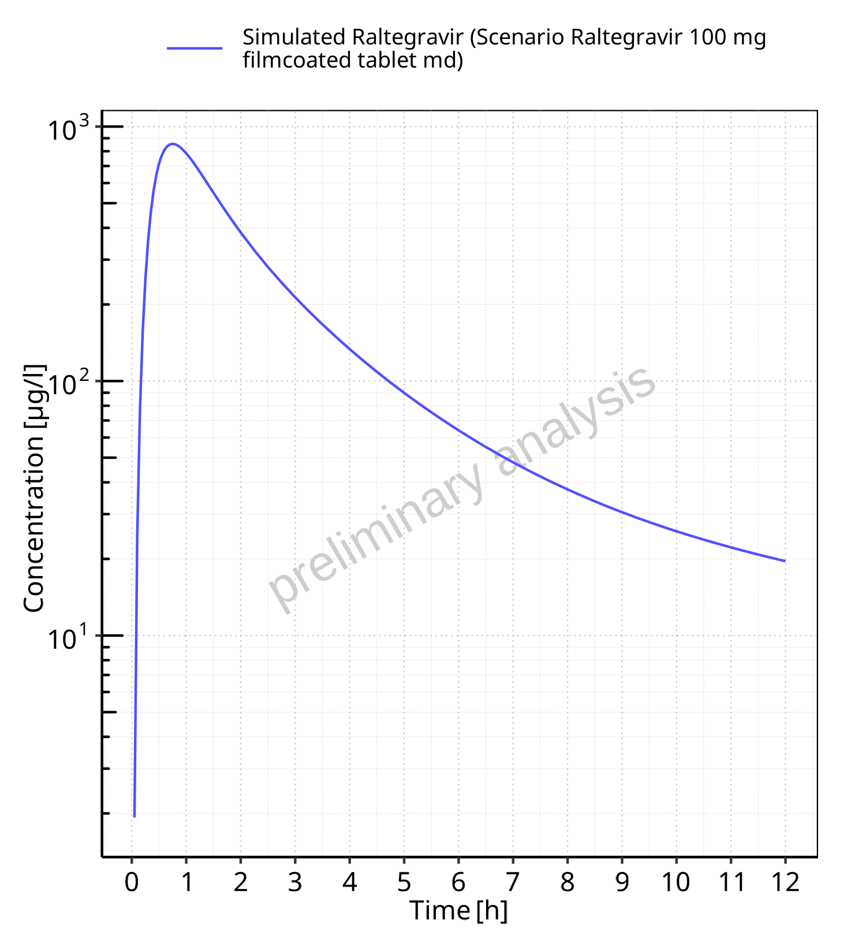

**Figure 5-10: Time profiles for Scenario Raltegravir 100 mg filmcoated tablet md. Data source: Data/Raltegravir_PK.txt. Time profiles are plotted in a logarithmic scale.**

### For last application range

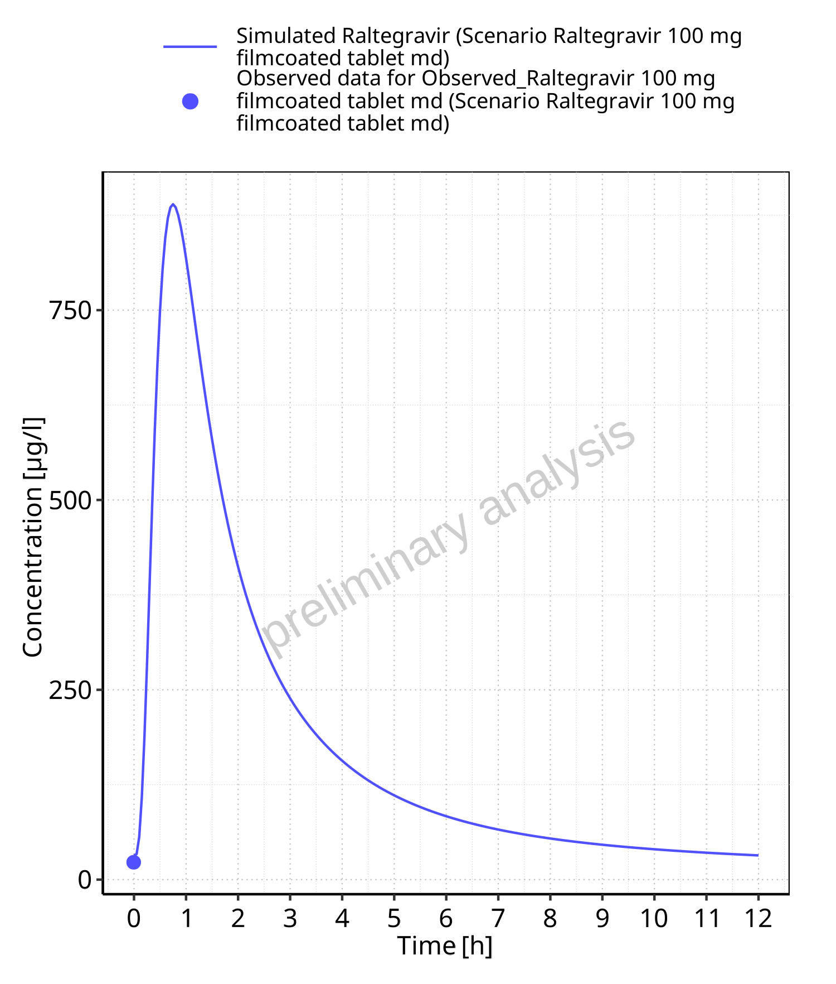

**Figure 5-11: Time profiles for Scenario Raltegravir 100 mg filmcoated tablet md. Data source: Data/Raltegravir_PK.txt. Time profiles are plotted in a linear scale.**

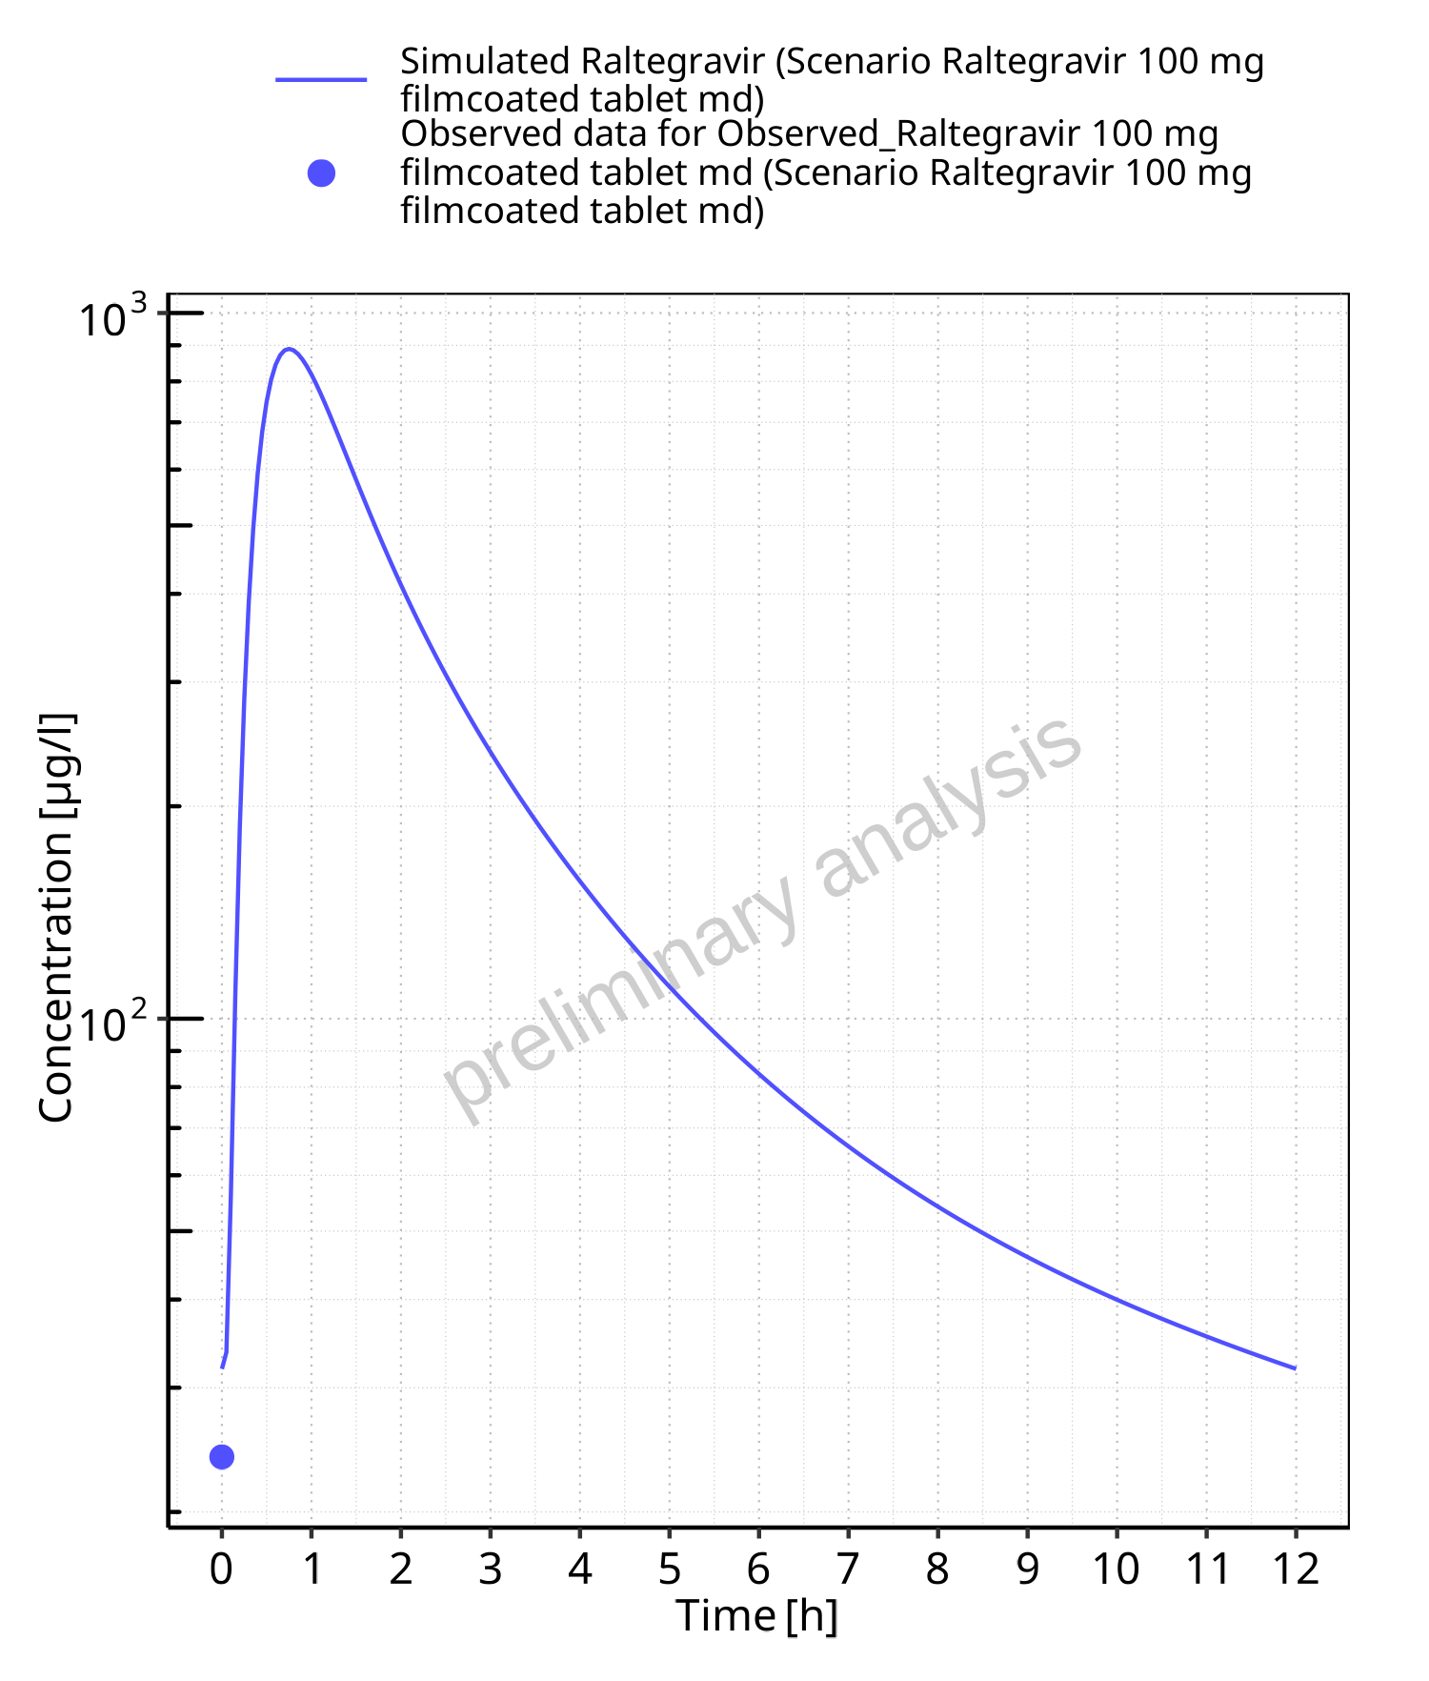

**Figure 5-12: Time profiles for Scenario Raltegravir 100 mg filmcoated tablet md. Data source: Data/Raltegravir_PK.txt. Time profiles are plotted in a logarithmic scale.**

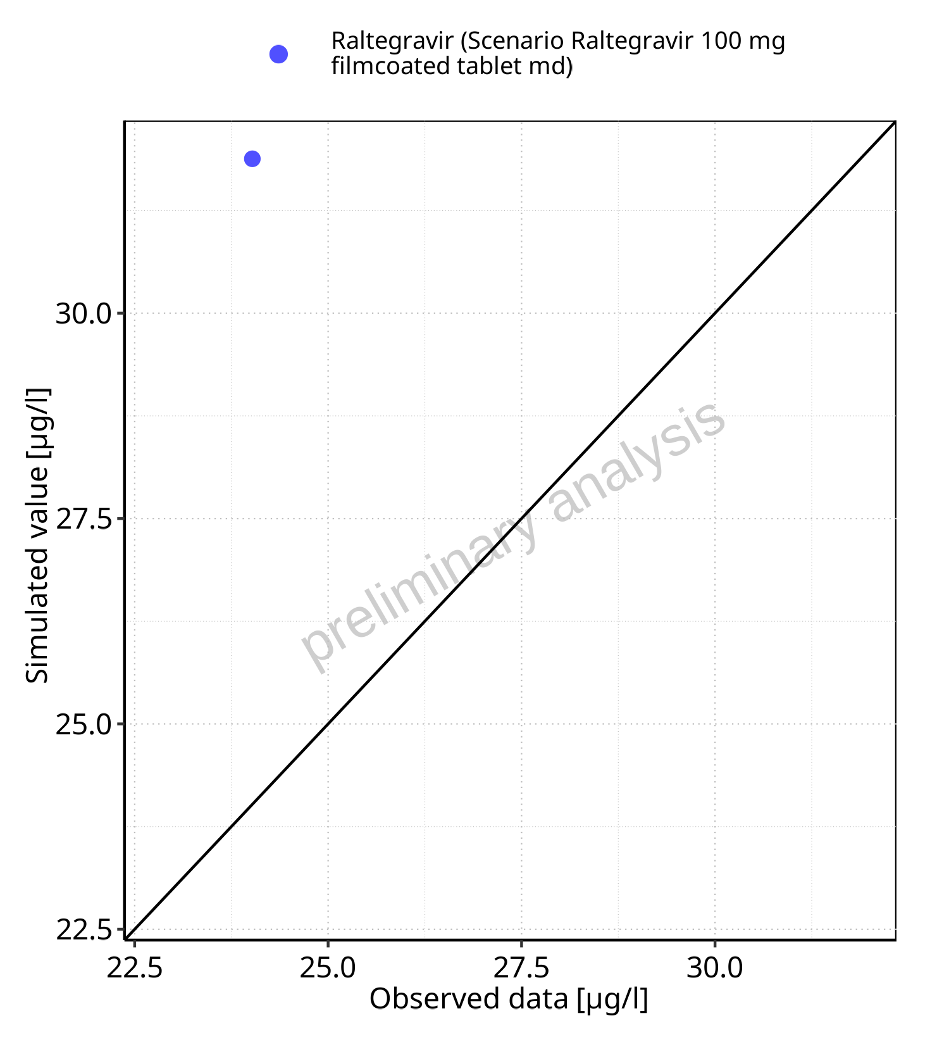

**Figure 5-13: Predicted vs observed for Scenario Raltegravir 100 mg filmcoated tablet md. Data source: Data/Raltegravir_PK.txt. Predictions and observations are plotted in a linear scale.**



**Figure 5-14: Predicted vs observed for Scenario Raltegravir 100 mg filmcoated tablet md. Data source: Data/Raltegravir_PK.txt. Predictions and observations are plotted in a logarithmic scale.**

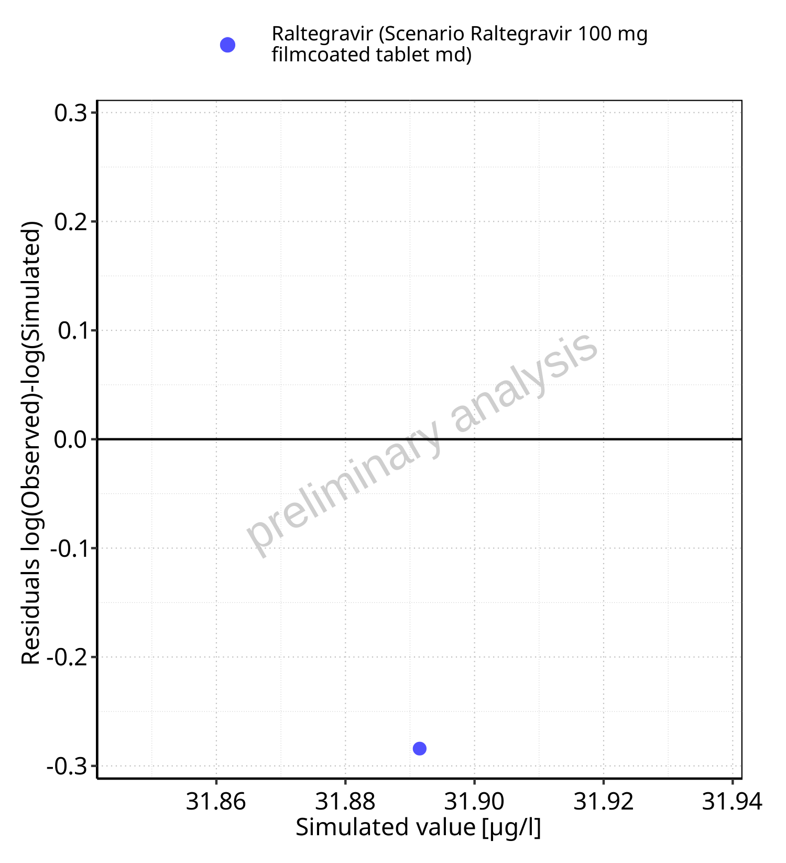

**Figure 5-15: Logarithmic residuals vs predicted values for Scenario Raltegravir 100 mg filmcoated tablet md. Data source: Data/Raltegravir_PK.txt.**

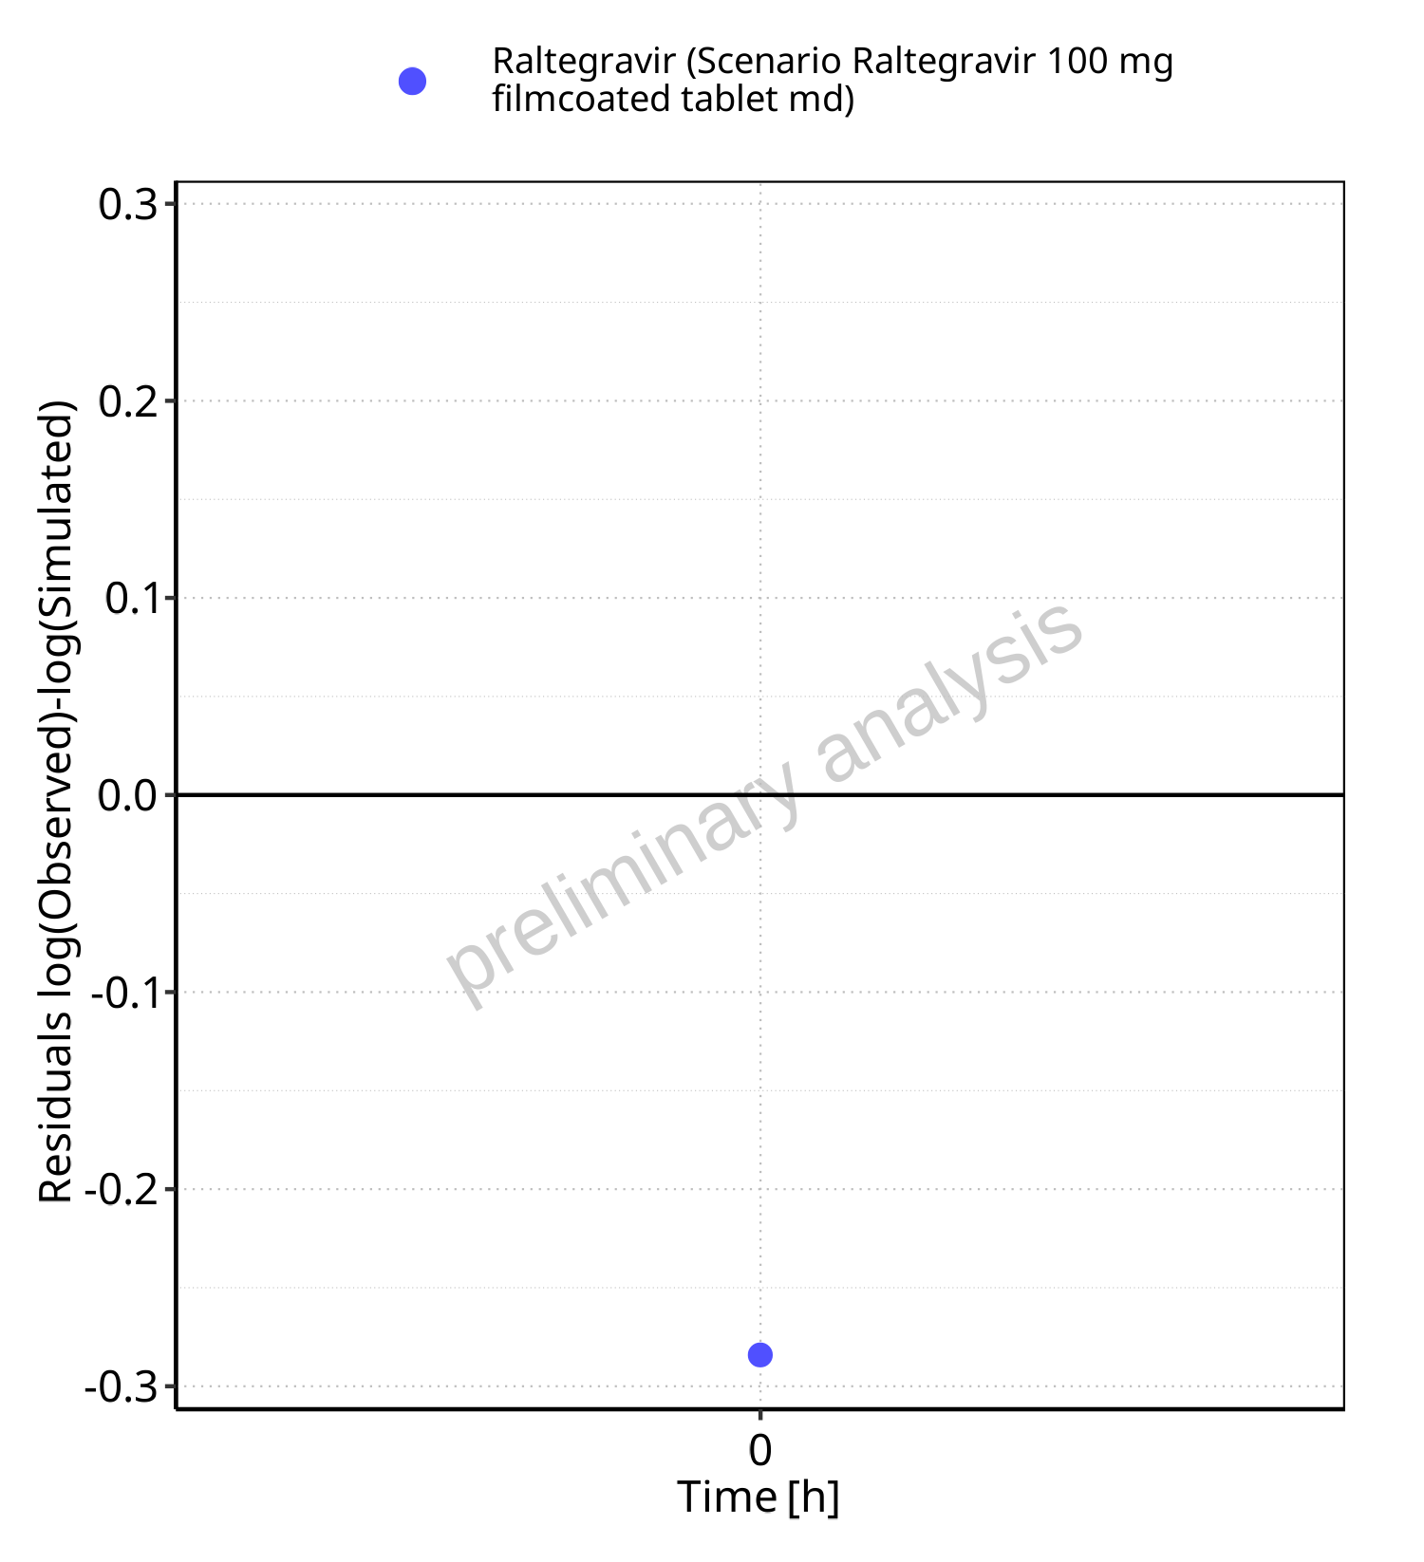

**Figure 5-16: Logarithmic residuals vs time values for Scenario Raltegravir 100 mg filmcoated tablet md. Data source: Data/Raltegravir_PK.txt.**

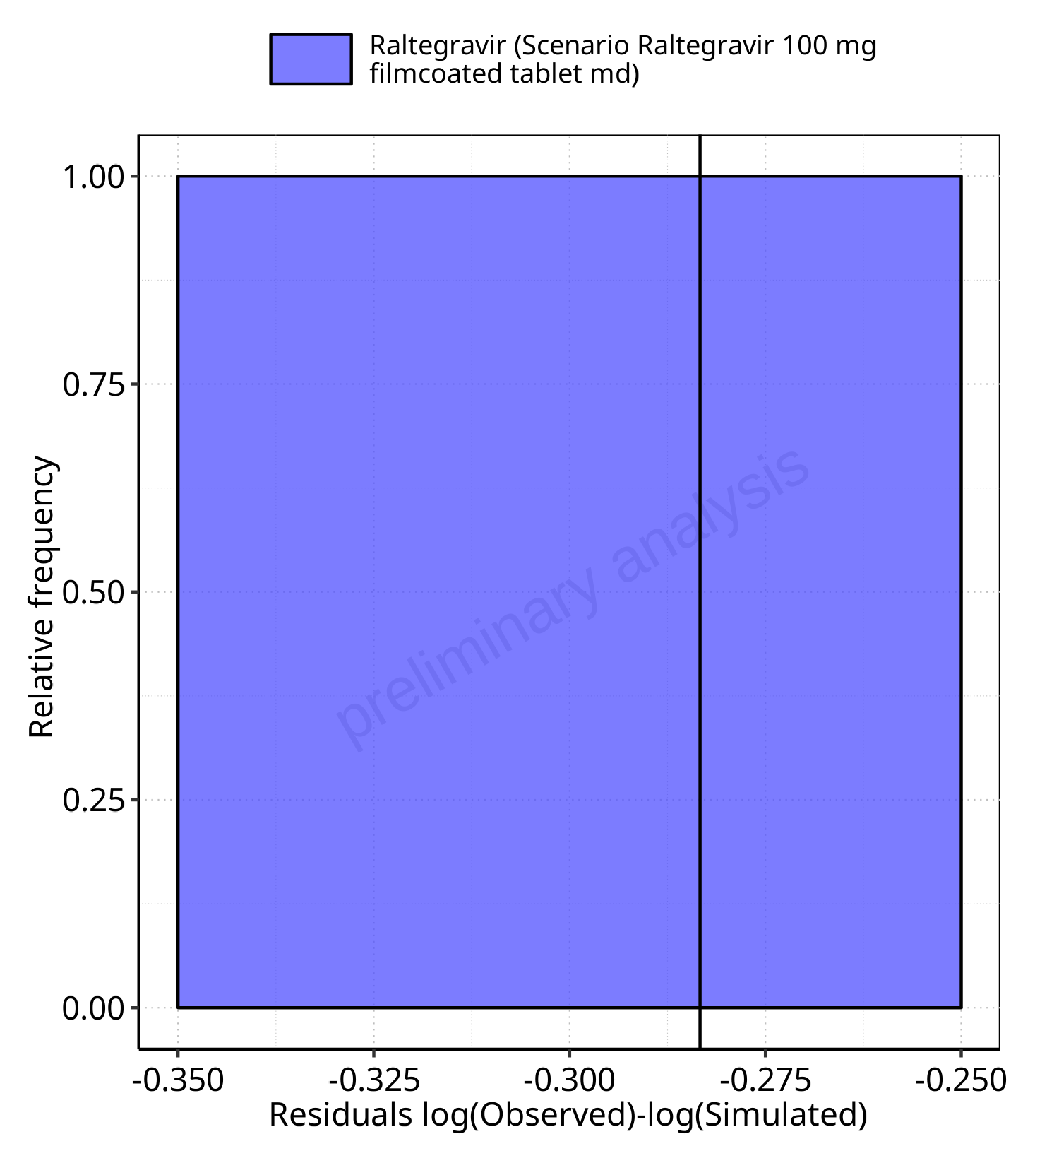

**Figure 5-17: Logarithmic residuals distribution (stacked) for Scenario Raltegravir 100 mg filmcoated tablet md. Data source: Data/Raltegravir_PK.txt.**

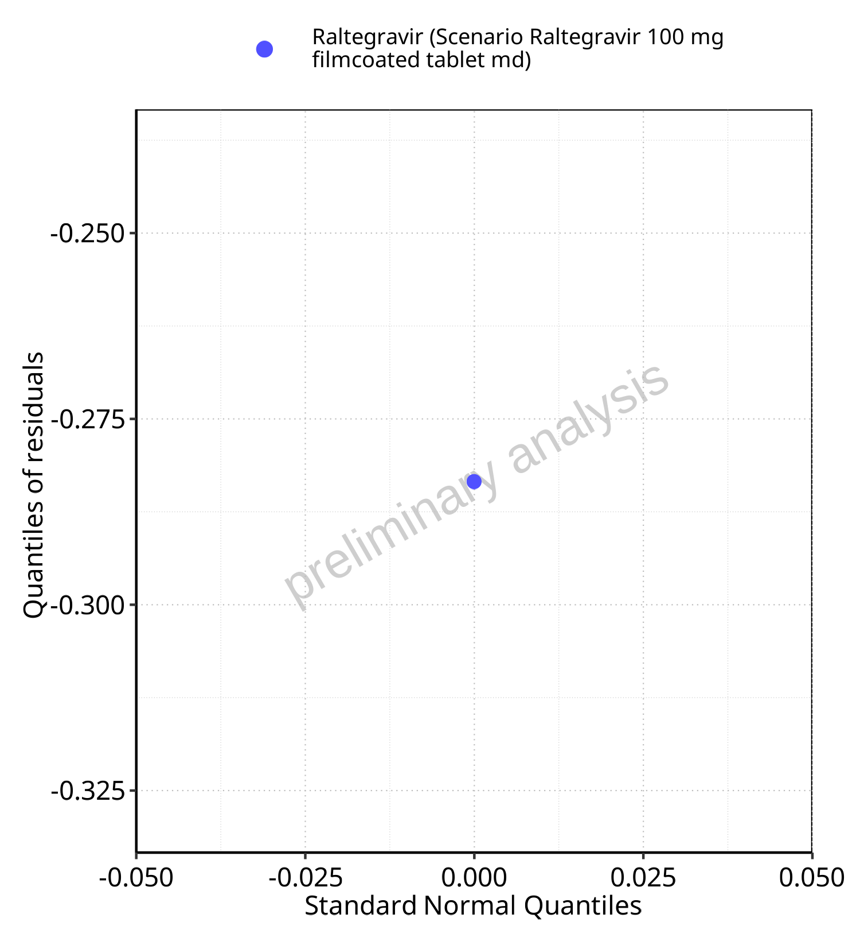

**Figure 5-18: Logarithmic residuals for Scenario Raltegravir 100 mg filmcoated tablet md as quantile-quantile plot. Data source: Data/Raltegravir_PK.txt.**